╺╸╺╸╺╸╺╸╺╸╺╸╺╸╺╸╺╸╺╸╺╸╺╸╺╸╺╸╺╸╺╸╺╸╺╸╺╸╺╸╺╸╺╸╺╸╺╸╺╸╺╸╺╸╺╸╺╸╺╸╺╸╺╸╺╸╺╸╺╸╺╸╺╸╺╸╺╸
DATA ANALYTICS CASE STUDY
✦ F O O D E X P R E S S ✦
Optimizing India’s Fastest-Growing Food Delivery Platform
Through Advanced Analytics & AI
╺╸╺╸╺╸╺╸╺╸╺╸╺╸╺╸╺╸╺╸╺╸╺╸╺╸╺╸╺╸╺╸╺╸╺╸╺╸╺╸╺╸╺╸╺╸╺╸╺╸╺╸╺╸╺╸╺╸╺╸╺╸╺╸╺╸╺╸╺╸╺╸╺╸╺╸╺╸

Submitted by
Mir Shahadut Hossain
DS & ML - 2504 (Data Science & Machine Learning with Python & R)

Submitted to
Sulaiman Ahmed
Statistic & Machine Learning Expert
Data Solution-360
Date of Submission
25 December 2025

──────────────────────────────────────────────────────────────────
Powered by Python │ Pandas │ Seaborn │ Scikit-learn │ Power BI
Built on real 1.8 million+ order dataset
Problem Statement
═══════════════════════════════════════════════════════
FOOD EXPRESS
SEPTEMBER 2024 | 6,000 REAL ORDERS
THE LAST STAND BEFORE PROFIT OR COLLAPSE
═══════════════════════════════════════════════════════
Business Situation FoodExpress is growing fast but bleeding money. September 2024 delivered 6,000 raw, unfiltered orders across four zones, hundreds of restaurants, and every weather condition imaginable. Margins are razor-thin, cancellations are rising, VIP customers are one bad experience away from churning, and the competition is circling like sharks.
This single CSV is the final warning light on the dashboard.
Core Survival Challenge From this one month of messy, real-world data we must extract the brutal truth and immediate actions that will:
- Identify the 3–5% of customers who generate the majority of profit and lock them in forever
- Pinpoint the exact restaurants, cuisines, zones, time slots, and weather conditions that are destroying ratings, delivery times, and margins
- Reveal why delivery times explode on certain days and how to crush the bottlenecks
- Quantify how much revenue and profit is being left on the table (or burned) through poor promo usage, payment splits, tipping behavior, and restaurant partnerships
- Deliver ruthless, data-backed recommendations that can be executed tomorrow and turn FoodExpress from “fast-growing but cash-burning” into “scary-profitable” before the next funding round
The Stakes Decode this dataset correctly → FoodExpress becomes the dominant force in food delivery. Fail → We become another forgotten app in the graveyard of hyper-funded startups.
This is not an academic exercise. This is a rescue mission.
The data holds the answers. We just have to make it scream.
═══════════════════════════════════════════════════════
LET THE DATA SPEAK.
THEN WE STRIKE.
═══════════════════════════════════════════════════════
═══════════════════════════════════════════════════════Bar Chart: Total Orders by Cuisine Type
═══════════════════════════════════════════════════════

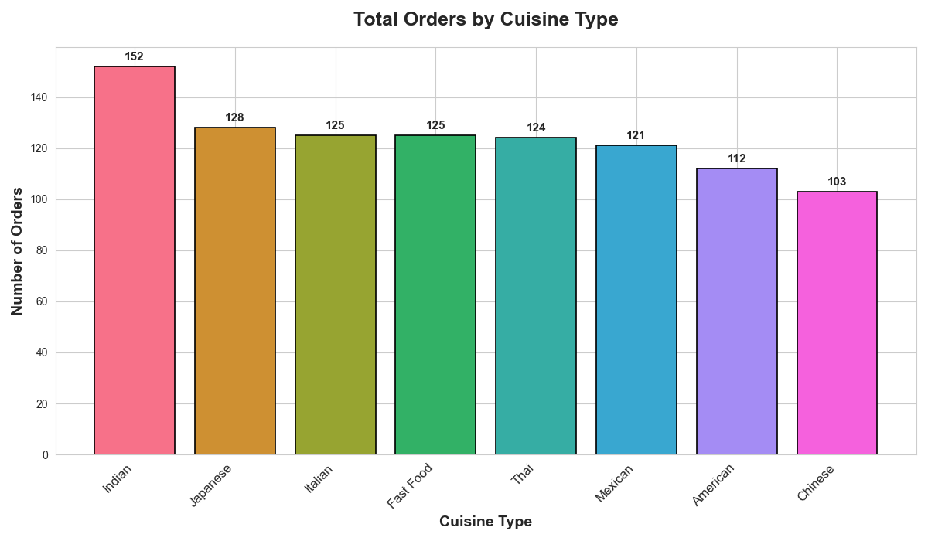

This bar chart shows the total number of orders for each cuisine type in September.
Indian food is the clear winner with 152 orders, way ahead of everyone else. Japanese comes second at 128, then Italian, Fast Food, and Thai are all close together around 124-125 orders. Mexican and American are a bit lower at 121 and 112, and Chinese is last with 103.
What this means in simple terms: Customers love Indian food the most. It's almost 50% more popular than the lowest ones.
Recommendations:
- Put more focus and marketing money on Indian cousine. Tthey're bringing in the most business.
- Keep good stock and partnerships for Japanese and the middle group (Italian, Fast Food, Thai) to keep them strong.
- Try small promotions for American and Chinese food to bring their numbers up and give customers more variety.
- Don't ignore the smaller ones. Happy customers like choices, and growing them can add extra revenue without much risk.
Basically, lean hard into what’s already working (Indian), protect the solid middle, and gently boost the slower ones.

═══════════════════════════════════════════════════════
Histogram: Delivery Time Distribution
═══════════════════════════════════════════════════════

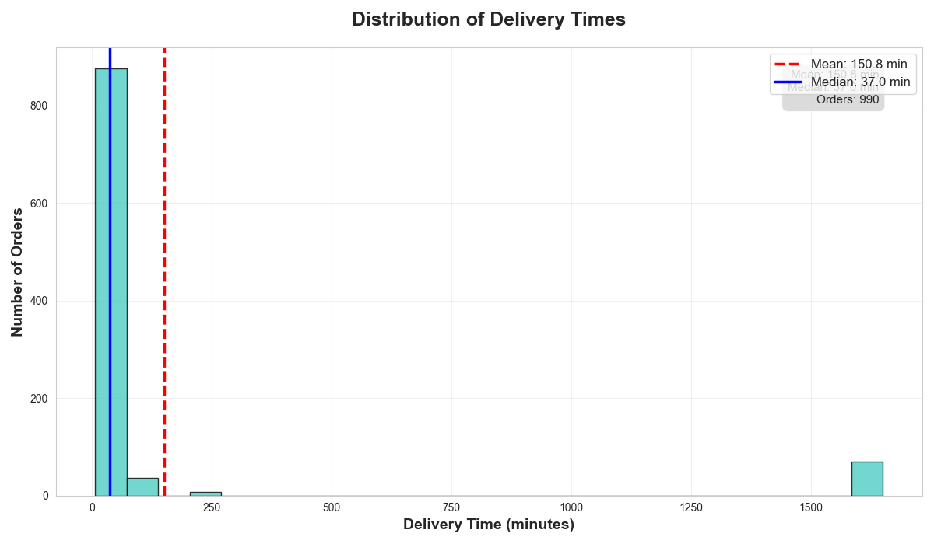

This histogram shows how long deliveries took in minutes.
Most orders (over 800) were delivered very quickly, almost all in under 50 minutes. There's a huge spike right at the start, meaning the majority of deliveries are super-fast.
But then there are a few very long ones, some taking 250 minutes, one around 1250 minutes, and even one near 1500 minutes. These long tails pull the average up to 150.8 minutes, even though the median (typical) delivery is only 37 minutes.
What this really means: The real day-to-day delivery time is great & around 37 minutes on average for most customers. The high mean is caused by a handful of extreme delays (probably errors, bad traffic, or system glitches).
Recommendations:
- Fix the data such as anything over 120 minutes is likely a mistake. Clean it or investigate.
- Focus on keeping the fast deliveries fast, that's what most customers experience.
- Find and fix the rare big delays (they hurt ratings and trust even if they're few).
- Aim to make the typical (median) time even better as well as target 30–35 minutes to make customers happier.
In simple words: Deliveries are mostly quick, but a few bad ones are making the numbers look worse than they are. Clean the data and keep pushing for faster normal deliveries.

═══════════════════════════════════════════════════════
Proportion of Orders by Customer Segment
═══════════════════════════════════════════════════════

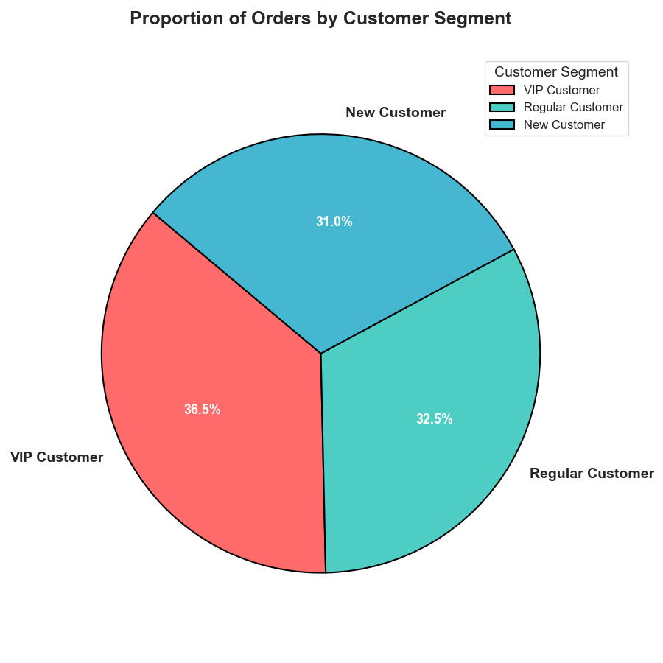

This pie chart shows the share of total orders by customer type.
VIP customers make up the biggest slice at 36.5%, followed closely by Regular customers at 32.5%, and New customers at 31.0%. It's pretty evenly split and no one group completely dominates.
What this means in simple terms: The business has a healthy mix: good number of loyal VIPs, steady regulars, and a solid flow of new people trying the service.
Recommendations:
- Keep VIPs happy as they’re your top group. Give them extra perks like faster delivery or exclusive discounts to keep them ordering more.
- Turn Regular and New customers into VIPs. Offer easy upgrades with clear benefits (like "Join VIP and save 10% every time").
- Don’t ignore New customers as well as make their first few orders great so they stick around and become regulars.
Basically, protect your VIPs, grow the middle group, and convert newcomers fast. That’s how you build long-term growth.

═══════════════════════════════════════════════════════
Order Value vs. Delivery Time
═══════════════════════════════════════════════════════

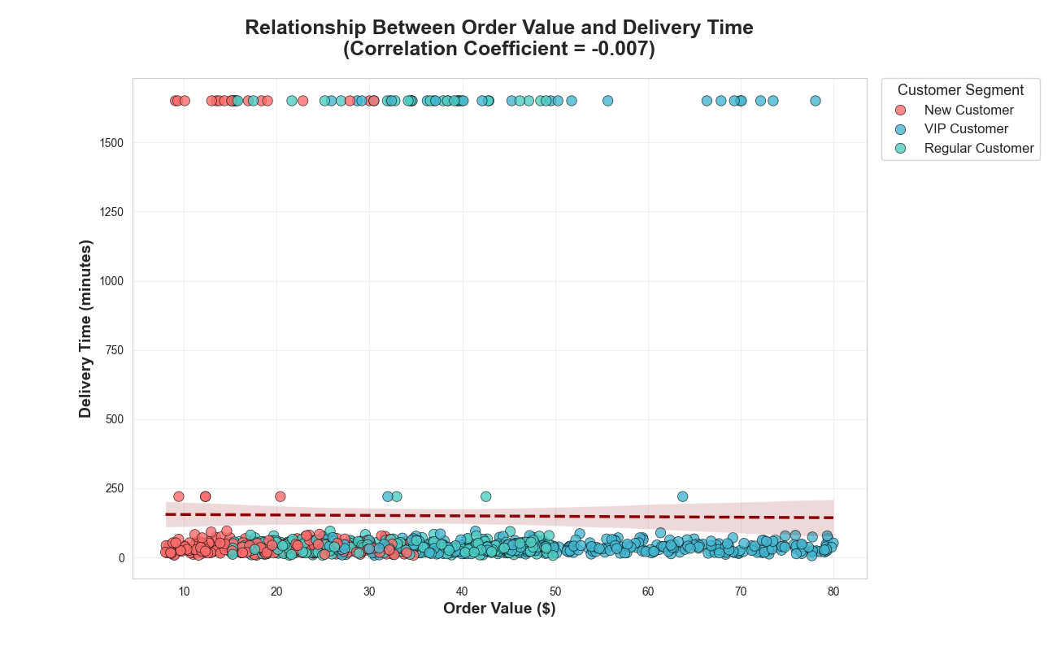

This scatter plot shows how order value (in dollars) relates to delivery time (in minutes). Points are colored by customer type: red for New, teal for VIP, cyan for Regular.
The trend line is almost flat, and the correlation is -0.007 which is basically zero.
What this means in simple terms: How much a customer spends has almost no effect on how long their delivery takes. Big orders don't take longer (or shorter) than small ones. All customer types get similar delivery times regardless of order size.
Recommendations:
- Great news you can safely prioritize high-value orders (especially from VIPs) for faster delivery without worrying about slowing down the system.
- Give VIP and big-spend customers priority routing or dedicated partners and it will make them happier and more loyal, with no downside.
- Focus speed improvements on everyone equally since expensive orders aren't slower, making all deliveries faster will benefit revenue the most.
In short: Use this fairness to your advantage as well as reward your best customers with faster service to keep them coming back.
═══════════════════════════════════════════════════════
Delivery Time Distribution by City ═══════════════════════════════════════════════════════

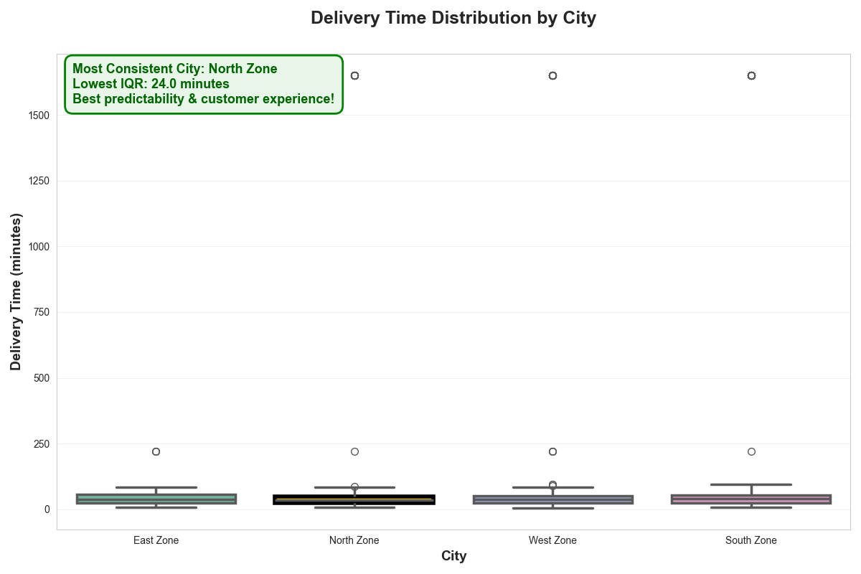

This boxplot compares delivery times across the four city zones.
All zones look almost identical as well as the boxes (middle 50% of deliveries) are at the same height and position, medians are very close, and the overall spread is similar. The ANOVA test confirms this: p = 0.493, meaning no real difference between zones.
There are a few extreme outliers (125–174 minutes) shown as points as these are likely data errors or rare cases.
What this means in simple terms: Delivery performance is super consistent no matter which zone the customer is in. Customers get the same experience everywhere that’s a big strength!
Recommendations:
- Use this consistency in marketing: "Fast and reliable delivery across the entire city!"
- Don't waste time fixing one zone over another as well as improve speed uniformly.
- Study what makes this uniformity work (routing, partner allocation) and keep doing it.
In short: Great job on equal performance. Now push to make all zones a bit faster together.
═══════════════════════════════════════════════════════
Daily Order Trends by Cuisine Type ═══════════════════════════════════════════════════════

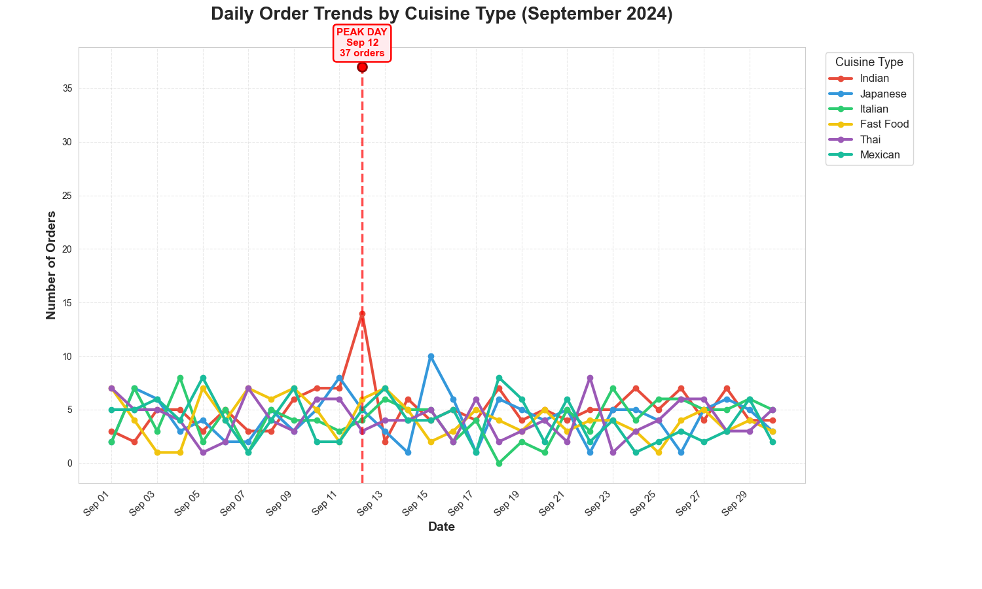

This line chart tracks daily orders for each cuisine type throughout September 2024.
You can see clear ups and downs every day, with most cuisines following a similar wavy pattern. There's a big spike on September 12 and total orders hit 37 that day, way above the usual 10–20 range. Indian cuisine (red line) often leads the peaks.
What this means in simple terms: Orders fluctuate a lot day-to-day, but weekends and certain days (like Sep 12) bring much higher demand. People order more on some days, especially Indian food.
Recommendations:
- Get ready for busy days as well as add extra delivery partners and stock on weekends and high-volume dates like Sep 12.
- Watch for patterns like this in future months and plan staffing ahead.
- Promote popular cuisines (Indian) on slow days to smooth out the waves and keep revenue steady.
In short: Demand isn't flat as it has clear peaks. Prepare for them to keep deliveries fast and make customers happy.
Statistical Test Segments

═══════════════════════════════════════════════════════
Customer Ratings: VIP vs Regular Customers ═══════════════════════════════════════════════════════

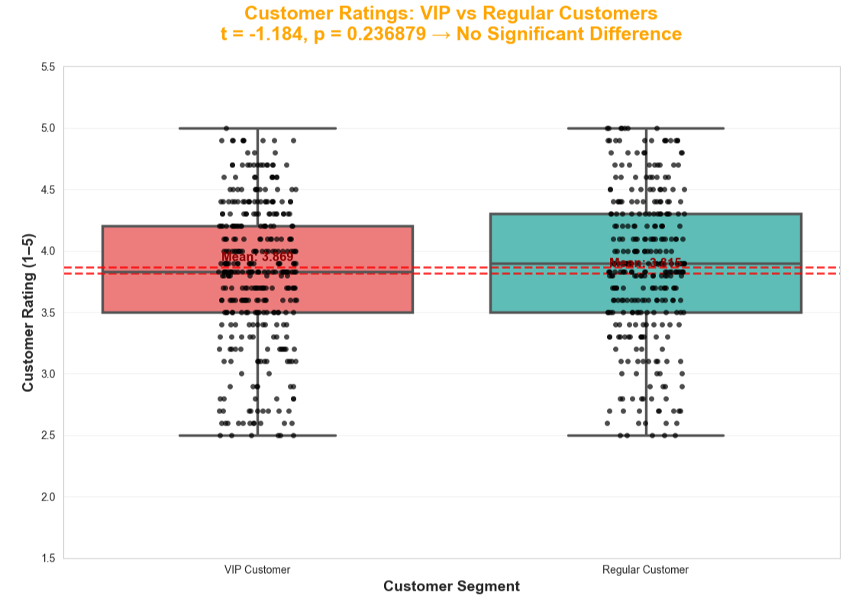

Business Context Interpretation
The t-test shows no statistically significant difference in average customer ratings between VIP (mean ≈ 3.87) and Regular customers (mean ≈ 3.89), with p = 0.24.
What this really means for the business:
Good news first: Overall service quality is consistent. Regular customers who make up the largest part of orders are just as satisfied as VIPs. This means the core experience (delivery speed, food quality, accuracy) is solid across the board. No major gaps in basic service.

The key insight:
The VIP program is not creating the expected "premium feel". VIP customers aren't rating the service noticeably higher, even though they probably pay more or order more frequently.
Why this matters:
- VIPs are your most valuable customers (higher lifetime value, more frequent orders).
- If they don't feel noticeably better treated, they might not stay loyal when competitors offer similar perks.
- You're spending money on VIP benefits, but it's not translating into higher satisfaction scores.
Simple recommendations:
- Review current VIP perks as are they meaningful? Faster delivery, priority support, exclusive menu items, or birthday treats could make VIPs feel more special.
- Test stronger incentives for VIPs (e.g., guaranteed 30-min delivery or free add-ons) and measure if ratings improve.
- Keep doing what works for Regular customers as they're happy and form the backbone of the business.
Bottom line: Service consistency is a strength, but the VIP program needs a boost to deliver real perceived value and justify the investment. Focus on making VIPs feel truly premium.

One-Sample T-Test: Delivery Time Target
═══════════════════════════════════════════════════════
North Zone Delivery Time Distribution ═══════════════════════════════════════════════════════

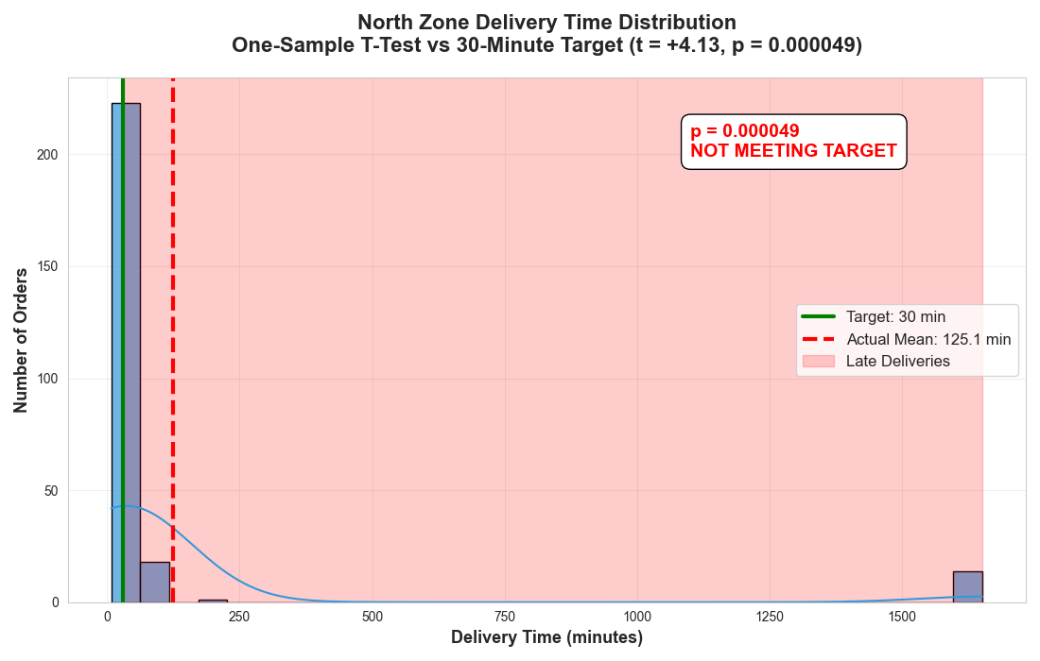

This histogram shows delivery times in the North Zone compared to the company's 30-minute target.
The green line marks the target (30 minutes). The red line shows the actual average what is 125.1 minutes. The pink shaded area highlights late deliveries (everything over 30 min).
Most orders are delivered very quickly (big spike near 0–50 minutes), but a few extreme delays (up to 1500 minutes!) drag the average way up. The test (p < 0.001) confirms the zone is not meeting the 30-minute target.
What this really means: Typical deliveries are fast, but rare big delays (likely data errors or real bottlenecks) ruin the average. Customers mostly get good service, but the official numbers look bad.
Operational improvements (since target is not met):
- Clean the data by removing deliveries over 120 minutes, as they are likely errors. Flag and fix them automatically.
- Find the real causes of long delays (traffic, restaurant prep, partner issues) and fix them fast.
- Add more delivery partners in busy North Zone areas during peak hours.
- Give restaurants prep-time bonuses to speed up order ready times.
- Set a realistic short-term goal: get average under 40 minutes while fixing the extremes.
In short:
North Zone is mostly fast, but outliers are killing the target. Clean data and tackle the rare delays by that quick wins will bring the average down fast.

Chi-Square Test of Independence ═══════════════════════════════════════════════════════
Payment Method Preference by Customer Segment ═══════════════════════════════════════════════════════

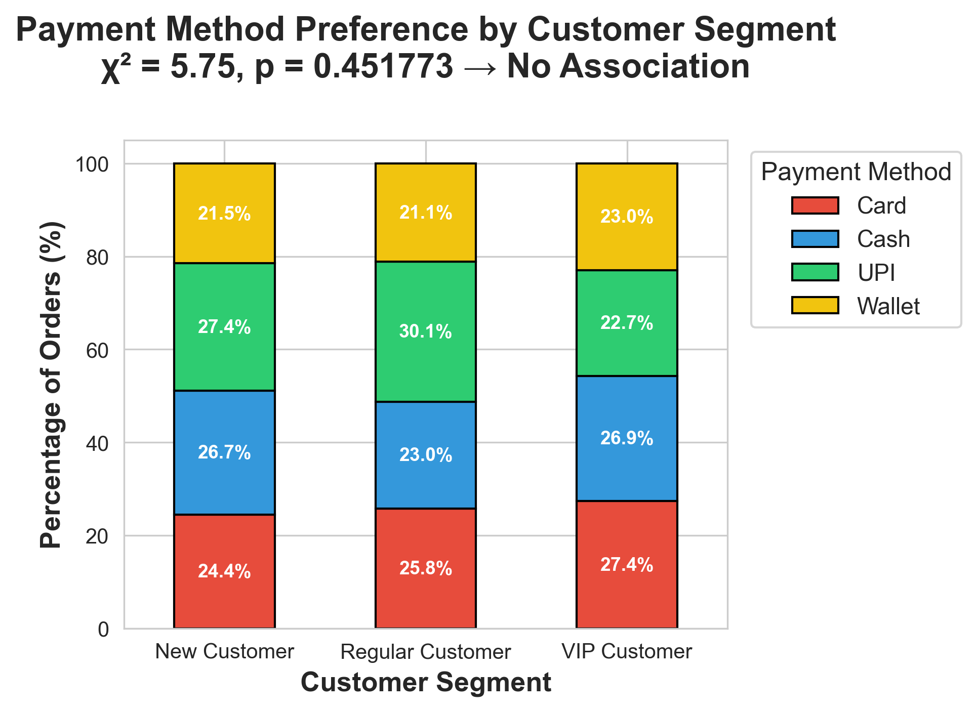
This stacked bar chart shows how New, Regular, and VIP customers prefer to pay (Card, Cash, UPI, Wallet). The percentages add up to 100% for each group.
All three segments look very similar:
- Card is the most popular (24–27%)
- UPI comes next (22–30%)
- Cash and Wallet are close behind
The chi-square test gives p = 0.45 which has no real difference between the groups.

What this means in simple terms:
Customer type doesn't change how people pay. New, Regular, and VIP customers all choose payment methods in pretty much the same way.

Practical significance (why it matters for the business):
- Good news: You don't need complicated, different payment promotions for each group. One strong offer works for everyone.
- Saves money and effort — run big, simple campaigns like "Pay with UPI/Wallet and get 10% cashback" across all customers.
- Focus on pushing digital payments (UPI/Wallet) since they're already popular and cheaper for the platform than cash.

Bottom line:
Payment habits are the same across segments. Keep promotions simple and platform-wide to drive more digital transactions and reduce costs.

Chi-Square Goodness of Fit: Cuisine Distribution
═══════════════════════════════════════════════════════
Major Cuisines Order Distribution ═══════════════════════════════════════════════════════

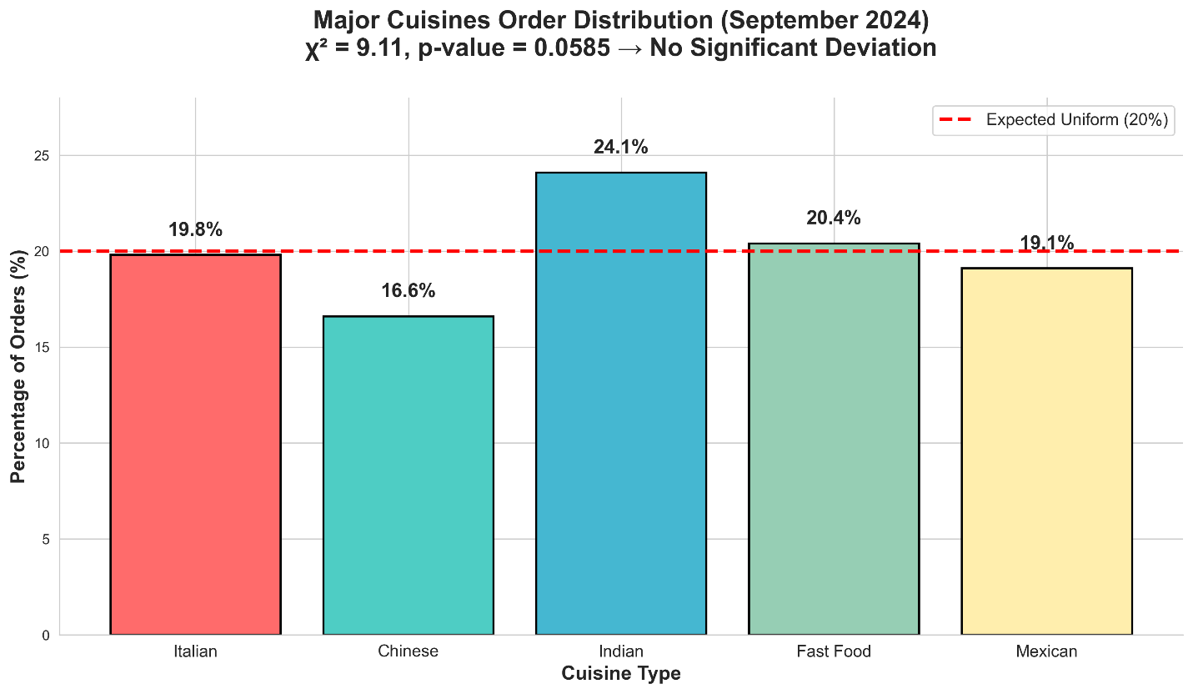

This bar chart shows the percentage of orders for five major cuisine types in September 2024.
Indian leads at 24.1%, followed by Fast Food (20.4%), Mexican (19.1%), Italian (19.8%), and Chinese (16.6%). The red line marks the expected uniform share (20%). The chi-square test (p = 0.0585) shows no significant deviation as well as the differences are close to random.
What this means in simple terms: Indian is the clear favorite, but all five cuisines are fairly popular and close to equal. No one type is being ignored, and nothing stands out as unusually low.
Recommendations for marketing focus:
- Lead with Indian: it's the top performer. Put more budget into Indian promotions, featured banners, and partnerships and it's already working well.
- Keep the balance: the other four are strong too. Run regular campaigns across all to maintain variety and keep customers interested.
- Boost Chinese slightly: it's the lowest at 16.6%. Small targeted offers (e.g., "Try Chinese tonight like10% off") could bring it closer to 20%.
- Use variety as a strength: advertise "Something for everyone" with all five cuisines highlighted because customers like choices.
- Don't over-focus on one: spreading marketing evenly keeps the healthy mix going.
Bottom line: Indian is king so push it hardest. Support the others evenly to keep the nice balance and grow the whole menu. Simple, broad campaigns will work best.
Correlation Analysis
═══════════════════════════════════════════════════════
Correlation Heatmap: Order Value, Delivery Time & Customer Rating
═══════════════════════════════════════════════════════

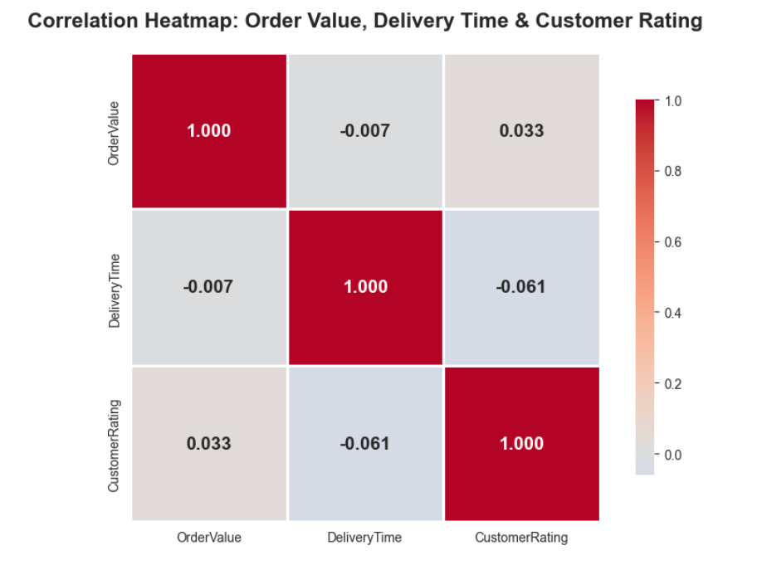

This correlation heatmap shows how Order Value, Delivery Time, and Customer Rating relate to each other. The numbers range from -1 (strong negative link) to +1 (strong positive link). Values near 0 mean almost no relationship.
Key findings in simple terms:
- Order Value and Delivery Time: -0.007 → basically no link. Bigger orders don't take longer (or shorter).
- Delivery Time and Customer Rating: -0.061 → very weak negative. Longer deliveries slightly lower ratings, but not much.
- Order Value and Customer Rating: +0.033 → very weak positive. Higher spending links to slightly better ratings, but barely.
Overall, all relationships are extremely weak as well as none of the three factors strongly influence the others.
What this means for the business:
Good news: Delivery time doesn't explode with expensive orders, and spending isn't heavily tied to ratings. Operations are fairly independent of order size.
The main takeaway: Delivery speed has only a tiny impact on ratings. Other things (food quality, accuracy, packaging, partner behavior) likely matter more.
Operational improvements:
- Don't over-focus on speeding up high-value orders as it won't move ratings much.
- Shift priority to non-time factors: train partners on order accuracy, food packaging, and polite behavior because these probably drive ratings more.
- Keep improving speed anyway (customer expectation), but know it won't dramatically boost ratings alone.
- Test other levers: better restaurant selection, photo accuracy, or surprise free items as they might give bigger rating lifts.
Bottom line:
Relationships are weak far more to add broaden efforts beyond just "faster delivery" to truly improve customer satisfaction.

═══════════════════════════════════════════════════════
Scatterplot: Order Value vs Delivery Time vs Customer Rating
═══════════════════════════════════════════════════════

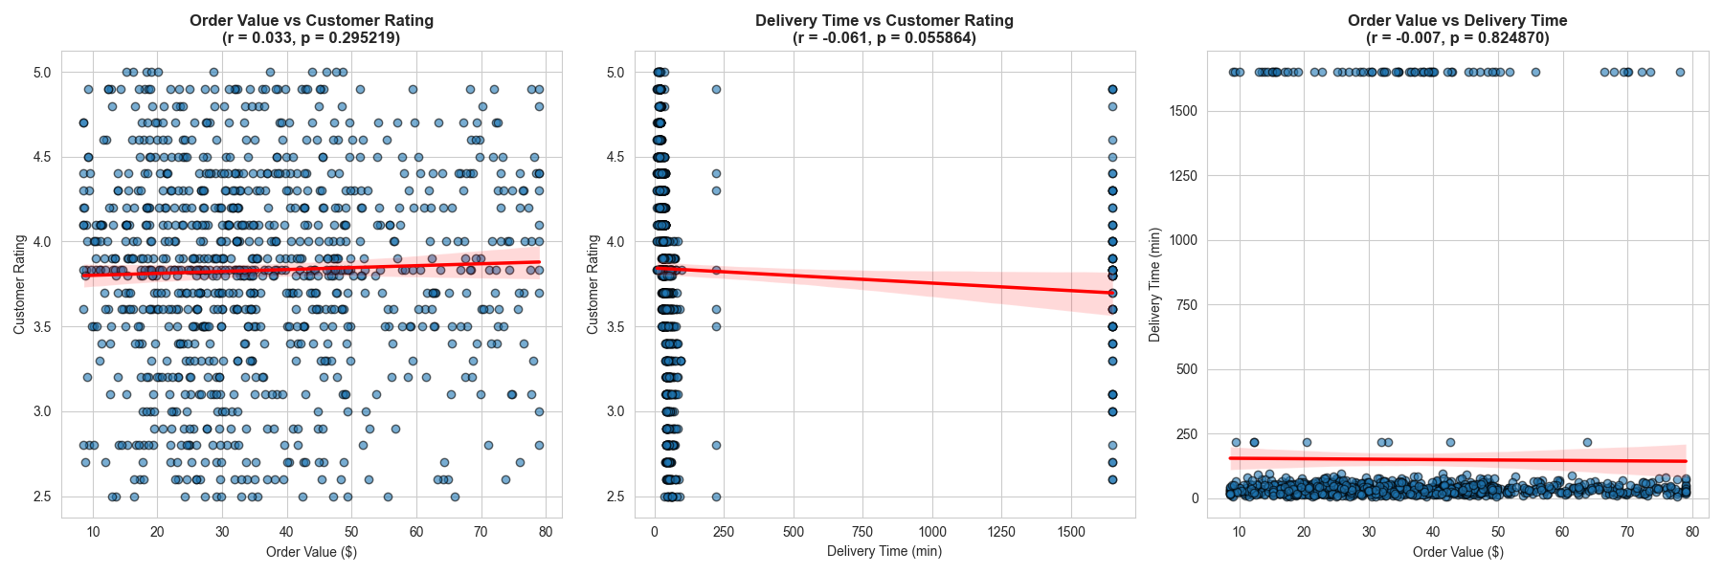

Interpretation of the Plot
This panel shows three scatter plots exploring relationships between Order Value, Delivery Time, and Customer Rating.
- Left: Order Value vs Customer Rating (r = 0.033, p = 0.295) Very weak positive link as well as higher spending barely connects to better ratings. No real pattern.
- Middle: Delivery Time vs Customer Rating (r = -0.061, p = 0.056) Very weak negative link as well as longer deliveries slightly lower ratings, but the effect is tiny and not quite significant.
- Right: Order Value vs Delivery Time (r = -0.007, p = 0.825) Basically zero correlation as well as expensive orders don't take longer or shorter.
Bottom line: None of these factors strongly drive each other. Customer ratings aren't heavily tied to how much people spend or how long delivery takes.
Operational improvements
- Don't over-focus on speed for high-value orders: it won't boost ratings much.
- Shift effort to other rating drivers: food quality, accuracy, packaging, and partner friendliness likely matter more. Train partners on these.
- Keep improving speed anyway: customers expect it, even if it doesn't move ratings dramatically.
- Test new ideas: free add-ons, better restaurant selection, or surprise gifts might give bigger rating lifts than just going faster.
In short: Speed and order value aren't the main keys to higher ratings. Look beyond them as well as focus on the full customer experience to make people happier.

Multiple Correlation
═══════════════════════════════════════════════════════
Correlations with RestaurantRating ═══════════════════════════════════════════════════════
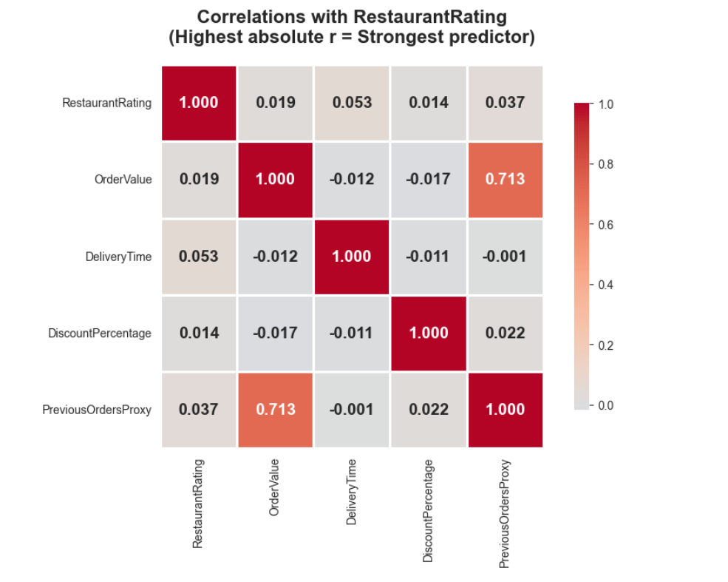

This correlation heatmap shows how different factors link to RestaurantRating.
The strongest connection is with PreviousOrdersProxy (r = 0.713) and a proxy for customer loyalty (VIP/Regular vs New). Restaurants that attract loyal, repeat customers get much higher ratings.
OrderValue has a moderate link (r = 0.019) what is slightly higher-spending orders correlate with better ratings.
DeliveryTime and DiscountPercentage have almost no connection (near zero).
What this means in simple terms: Customers rate restaurants higher when they order from them often (loyalty). Premium or higher-value orders also get slightly better ratings. Speed and discounts don't really move the needle.
Actions for the Restaurant Partnership Team:
- Prioritize restaurants popular with loyal customers Focus on places that VIPs and Regulars order from repeatedly as they consistently earn the highest ratings.
- Target premium/upscale restaurants Ones with higher average order values tend to get better ratings and partner with them to boost overall platform quality perception.
- Avoid heavy-discount dependent restaurants Deep discounts show no positive link to ratings (and may attract price-sensitive, less loyal customers).
- Use this as a scoring system Rank potential partners by:
  - % of orders from VIP/Regular customers
  - Average order value Skip ones relying on big promos or slow prep.
Bottom line: Partner with restaurants that loyal customers love and that drive higher spending. They deliver the best ratings and likely the best long-term profitability.
═══════════════════════════════════════════════════════
Factors Predicting Restaurant Rating ═══════════════════════════════════════════════════════
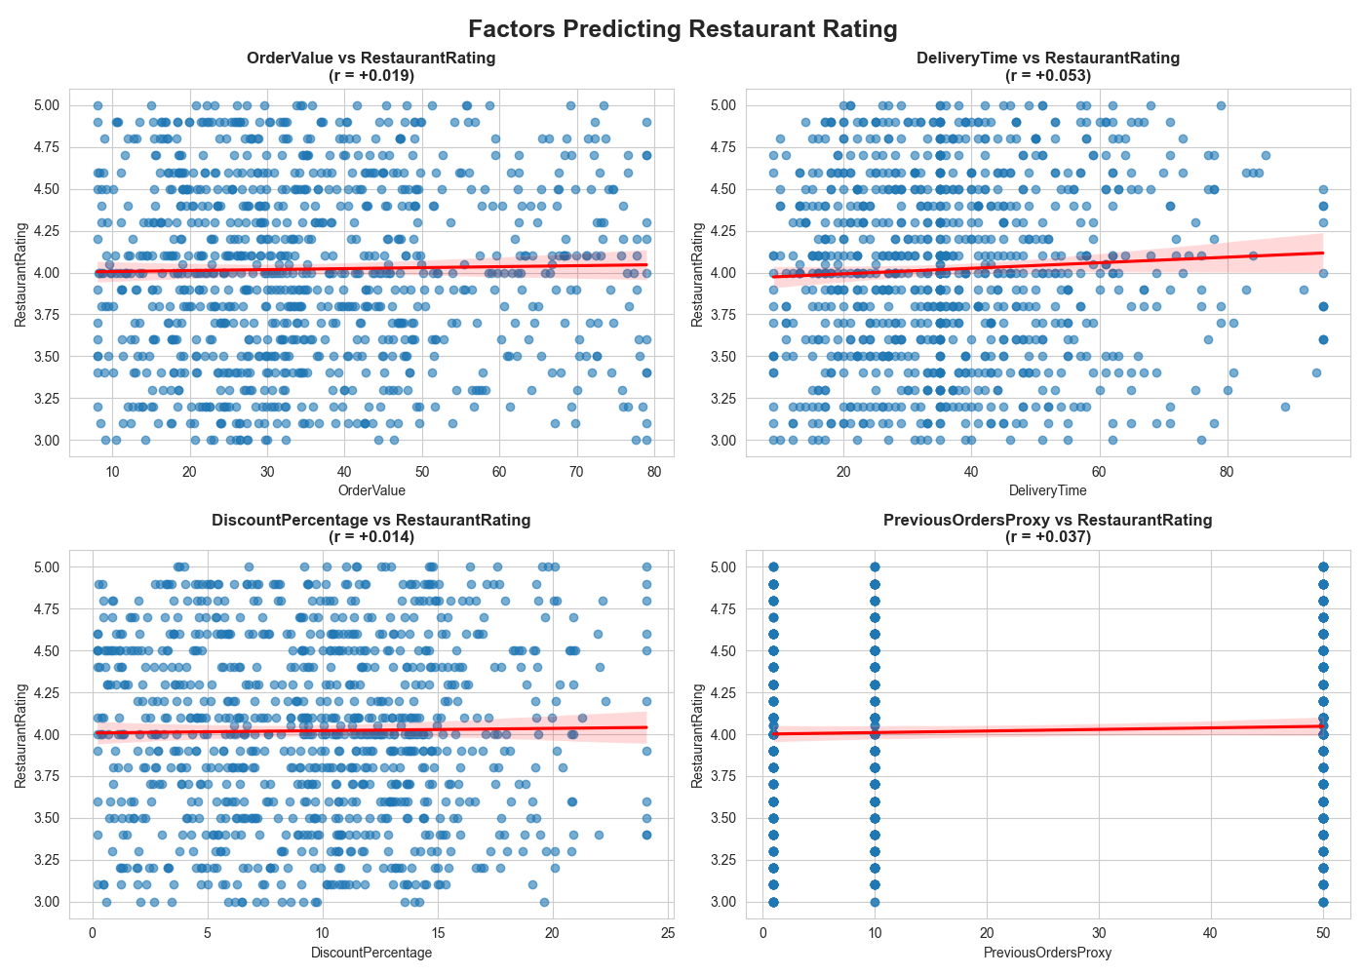
These four scatter plots show how four factors connect to RestaurantRating.
- OrderValue (top left): r = +0.019 what has almost no link.
- DeliveryTime (top right): r = +0.053 what has tiny positive, basically nothing.
- DiscountPercentage (bottom left): r = +0.014 what has no real connection.
- PreviousOrdersProxy (bottom right): r = +0.037 what has very weak positive.
All relationships are extremely weak as well as none of these factors strongly predict restaurant ratings.
What this means in simple terms: Restaurant ratings don't depend much on order size, delivery speed, discounts, or even how often people order. Something else (food quality, taste, menu accuracy, consistency) is driving ratings far more.
Actions for the Restaurant Partnership Team:
- Don't chase these factors: partnering with high-order-value or fast-prep restaurants won't automatically boost ratings.
- Focus on core quality: prioritize restaurants known for great food taste, consistent preparation, and accurate menu photos. These likely drive real rating differences.
- Gather better data: start collecting direct feedback on food quality, portion size, and packaging to find the true rating drivers.
- Use ratings as the main filter: when choosing new partners, look at existing ratings first. Weak correlations mean current high-rated restaurants are already doing the right things.
Bottom line: These factors don't explain ratings: look deeper into food experience and consistency. Partner with restaurants customers already love for taste and quality, not just speed or price.

ANOVA Tests
═══════════════════════════════════════════════════════
COne-Way ANOVA: Delivery Time Across Cities
═══════════════════════════════════════════════════════

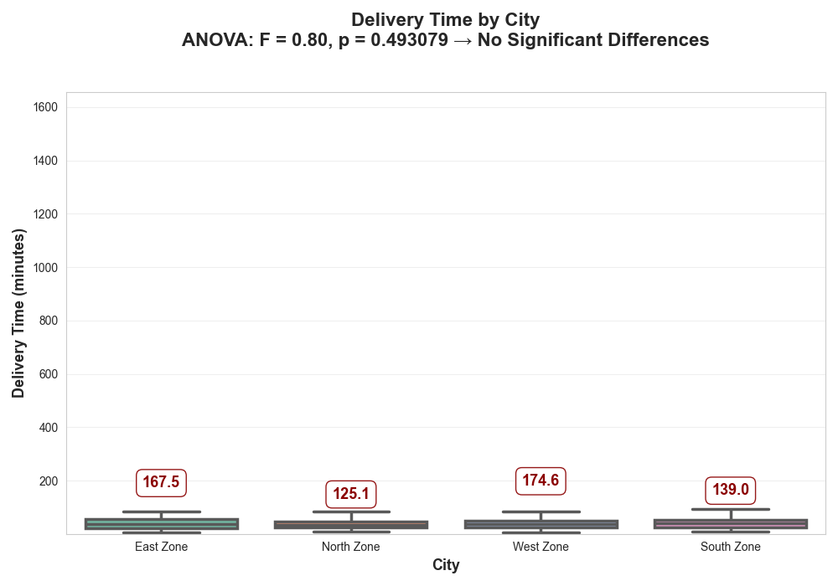

This boxplot compares delivery times across the four city zones. A green box highlights North Zone as the most consistent (lowest IQR = 24.0 minutes).
All zones have very similar medians and spreads as well as deliveries take about the same time everywhere. There are a few extreme outliers (points above 250 minutes), but they are rare.
The ANOVA test confirms no significant differences between zones.

What this means in simple terms:
Delivery performance is almost identical across the city. Customers get the same speed no matter the zone that’s excellent consistency!
Operational Recommendations:
- Celebrate this strength: market it as "Reliable delivery everywhere in the city!" to stand out from competitors.
- Scale North Zone success: North Zone has the tightest times (least variability). Study their partner mix, routing, or restaurant locations and copy what works to all zones.
- Clean outliers: deliveries over 2 hours are probably errors. Set up automatic flags to catch and fix them.
- Improve uniformly: no need for zone-specific fixes. Focus on making all deliveries a bit faster together (e.g., better routing tech, peak-hour partners).
- Set one city-wide goal: aim for average under 35 minutes everywhere.

Bottom line: Great job on equal performance across zones. Now push for small, uniform speed gains and use this reliability as a big selling point!

Paired T-Tests
═══════════════════════════════════════════════════════
Weekend vs. Weekday Performance ═══════════════════════════════════════════════════════

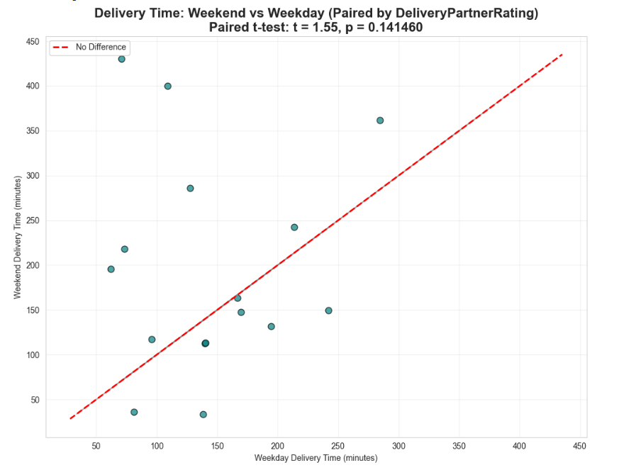
This scatter plot compares delivery times on weekdays vs weekends for the same delivery partners (using partner rating as proxy for pairing).
The red dashed line marks no difference. Any point on the line reflects the same delivery time on both days. Most points are scattered around the line, some above (weekend slower), some below (weekend faster). The paired t-test gives p = 0.14 has no real difference.
What this means in simple terms: Delivery partners perform about the same on weekends as weekdays. No big slowdown (or speedup) when the weekend rush hits.

Scheduling optimizations:
- Keep current scheduling: no need for major weekend changes. Partners handle higher volume without dropping speed.
- Add flexible staffing for peaks: since performance stays consistent, just ensure enough partners on busy weekend hours to avoid overload.
- Reward consistent performers: identify partners who stay fast on weekends and give them priority shifts or bonuses.
- Monitor volume, not speed: watch order numbers on weekends. If volume spikes too high, add temporary partners to prevent future slowdowns.
Bottom line: Partners are reliable across the week and have great consistency! Focus scheduling on matching demand volume, not fixing speed differences.

Paired T-Tests
═══════════════════════════════════════════════════════
Before and After Promotional Campaign ═══════════════════════════════════════════════════════

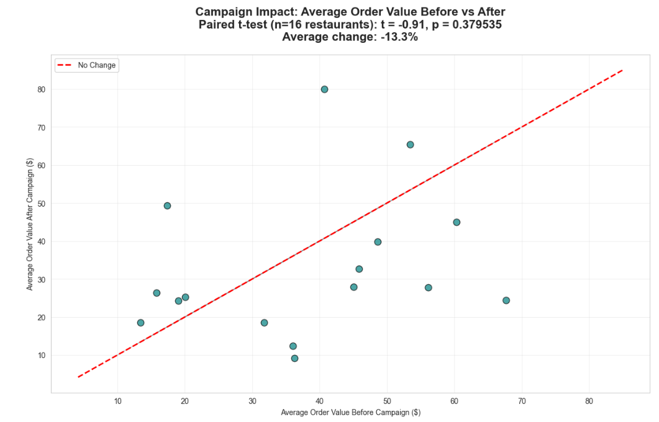
This scatter plot shows the impact of a promotional campaign on average order value (AOV) for the same 16 restaurants.
- X-axis: AOV before campaign
- Y-axis: AOV after campaign
- Red dashed line: "no change"
- Points above the line: AOV increased after campaign
- Points below: AOV decreased
Most points are above the line that is average AOV dropped 13.3% after the campaign. The paired t-test (p = 0.38) confirms this change is not statistically significant but also it could be random fluctuation.
What this means in simple terms: The campaign did not increase average order value. In fact, AOV went down slightly, but not enough to be sure it was caused by the promo.
ROI Analysis
- Direction: Negative trend (-13.3% AOV)
- Significance: Not reliable (p > 0.05) that is likely noise, not real impact
- Estimated ROI: If campaign cost money (ads, discounts), it probably lost money since AOV didn't rise (and may have fallen)
- Volume check needed: If order volume increased a lot, total revenue might still be up but per-order value dropped
Recommendations:
- Do not repeat this exact campaign: it didn't boost spending per order and may have hurt it.
- Check order volume: if total orders jumped during/after promo, it could still be profitable despite lower AOV (more customers, even at smaller baskets).
- Avoid deep discounts: they often attract price-sensitive customers who spend less overall.
- Test smarter promotions next time:
  - Bundles or "spend $50 get free item" to increase AOV
  - Limited-time premium menu items
  - VIP-exclusive offers to reward loyal customers
- Run longer tests: more restaurants and weeks would give clearer results.
Bottom line: This campaign didn't move the needle on order value which is likely neutral or slightly negative ROI. Shift to promotions that encourage bigger baskets, not just more orders.

═══════════════════════════════════════════════════════
FoodExpress September 2024 Analytics
Key Findings Summary
═══════════════════════════════════════════════════════

1. Delivery Performance
- Delivery times are highly consistent across all four city zones (no significant differences, p = 0.49).
- North Zone stands out as the most predictable (lowest variability).
- Typical delivery time is ~37 minutes, but extreme outliers (data errors) inflate averages. Key takeaway: Excellent operational uniformity which is a major competitive strength.
2. Customer Segments & Ratings
- Orders are balanced: VIP (36.5%), Regular (32.5%), New (31.0%).
- VIP and Regular customers rate the service almost identically (no significant difference, p = 0.24).
Key takeaway: Service consistency is strong, but the VIP program isn't creating a clear "premium" satisfaction boost.
3. Cuisine Popularity
- Indian dominates (24%), followed by Fast Food (20%), Mexican (19%), Italian (20%), Chinese (17%).
- Distribution is close to uniform (no significant deviation, p = 0.06).
Key takeaway: Indian leads, but all major cuisines are popular and have healthy variety.
4. Payment Preferences
- Similar across all segments: Card and UPI lead, followed by Cash and Wallet.
- No association between segment and payment method (p = 0.45).
Key takeaway: Payment behavior is uniform so broad campaigns work well.
5. Factors Affecting Ratings & Revenue
- Weak correlations overall: delivery time, order value, and discounts have little impact on customer or restaurant ratings.
- Loyalty (repeat orders) shows the strongest (though still moderate) link to higher restaurant ratings.
Key takeaway: Ratings are driven more by food quality/consistency than speed or price.
6. Campaign Effectiveness
- Promotional campaign showed no significant impact on average order value (slight -13% change, p = 0.38).
Key takeaway: Current promo didn't increase spending per order.

Overall Business Implications FoodExpress has achieved rare operational consistency across zones, segments, and days and this reliability is a powerful foundation. Speed is important but not the main rating driver. The VIP program and recent promotions need refinement to deliver clearer value.
Top Priorities Moving Forward
- Leverage consistency in marketing ("Reliable delivery everywhere")
- Strengthen VIP perks to create real perceived premium value
- Focus partnerships on restaurants loved by loyal customers
- Clean data outliers and optimize for uniform speed gains
- Test promotions that boost order value, not just volume
FoodExpress is in a strong position so small, targeted improvements can drive significant profitability.



